Some clarity sending mass emails to AD'S to find games, announce job openings, find officials and etc….

With the IHSADA going to Final Forms/Amp for registration last year, you as a member now have access to send your own emails to whatever groups you desire.

The steps to send an email via the Final Forms/Amp database are below.

You have to be an IHSADA member to send an email, but all non-members will still get the communications that are sent.

You can join today by clicking here: IHSADA Membership Registration Form.

The IGHSAU & IHSAA have a scheduling clearinghouse & Bound has the AD board you can post to.

Final Forms/Amp will allow you to email by conference & district.

See the directions below if you wish to start communicating that way and you are a member of the IHSADA.

You may also choose to watch this video for directions:
https://www.youtube.com/watch?v=NEIctk-zd38

EMAIL GROUPS by Conference, District, Sports & Division, etc. - IHSADA AMP COMMUNICATION
1. Click the ‘Members Directory’ link at the top of your screen
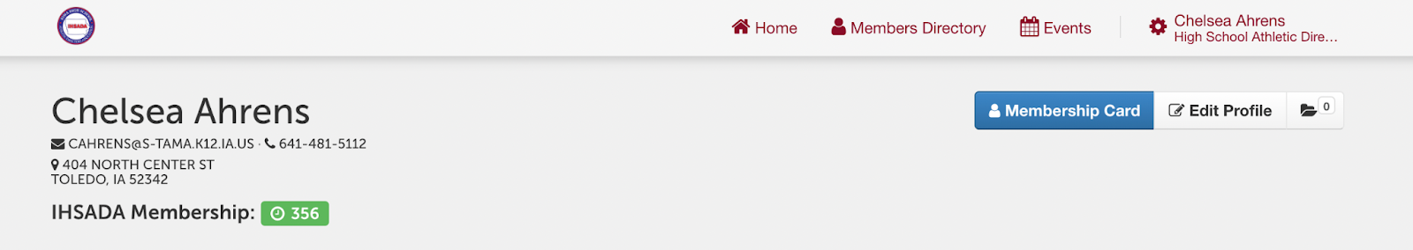
2. Locate the suggested ‘Filter/Sorts’ with check boxes
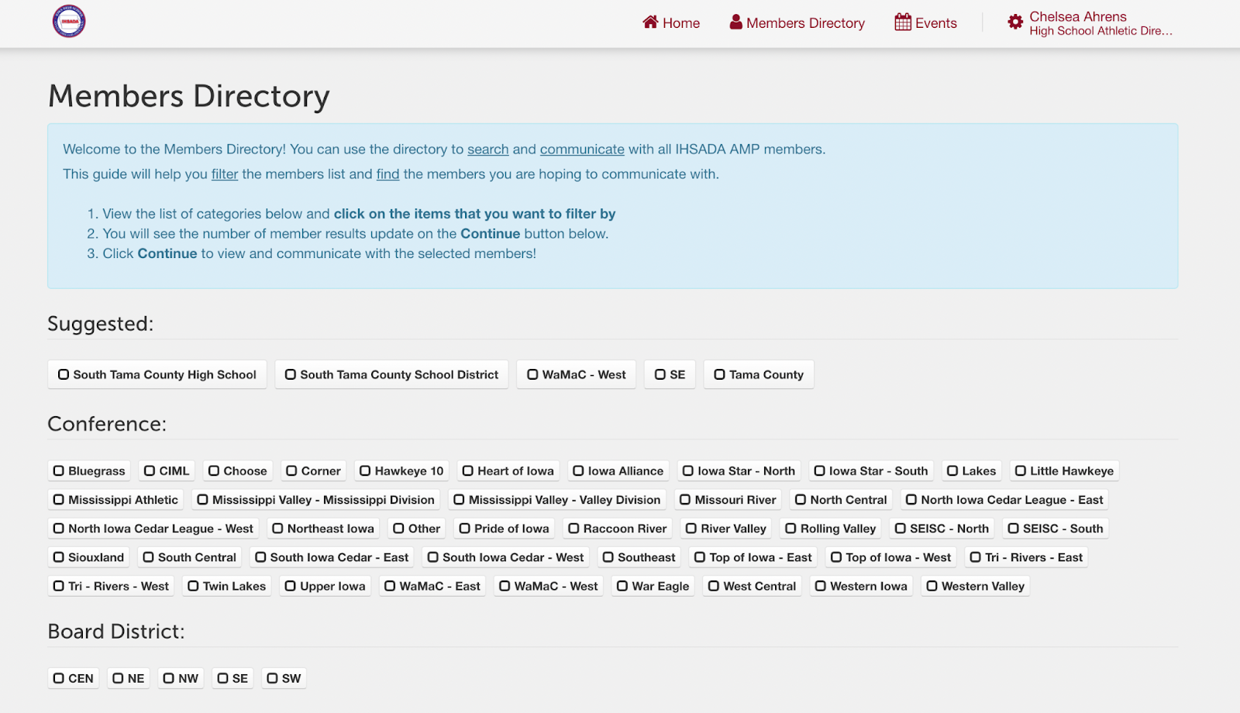
3. Please check the box(es) next to the Conference, Board District, County and/or Custom Group you want to filter by and select CONTINUE
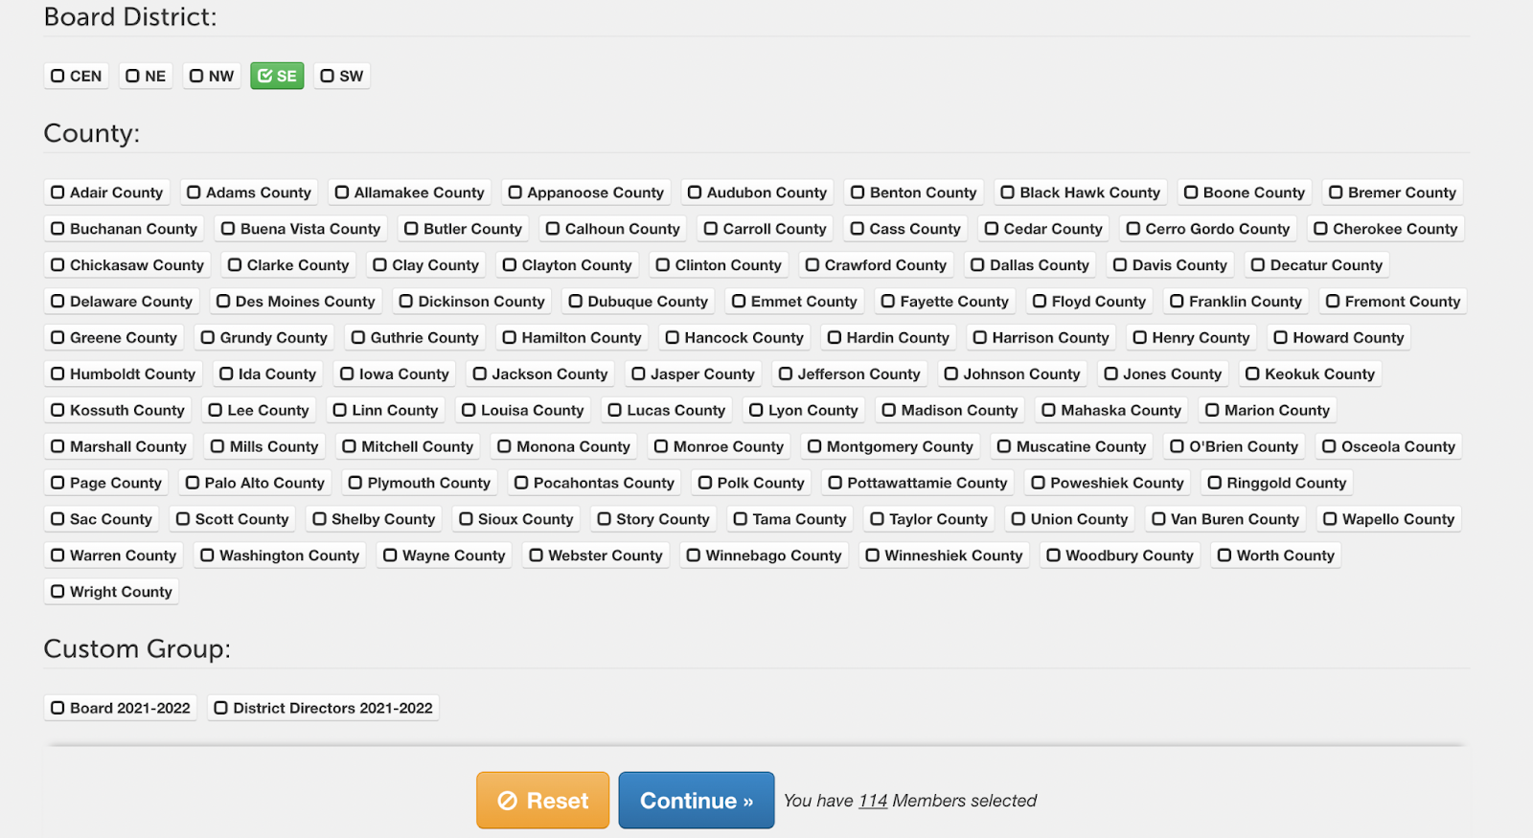
4. The AD members that belong to this filtered group will be pulled into a Bcc and proceed to the email by clicking on the MESSAGE SELECTED MEMBERS button at the bottom of the screen.
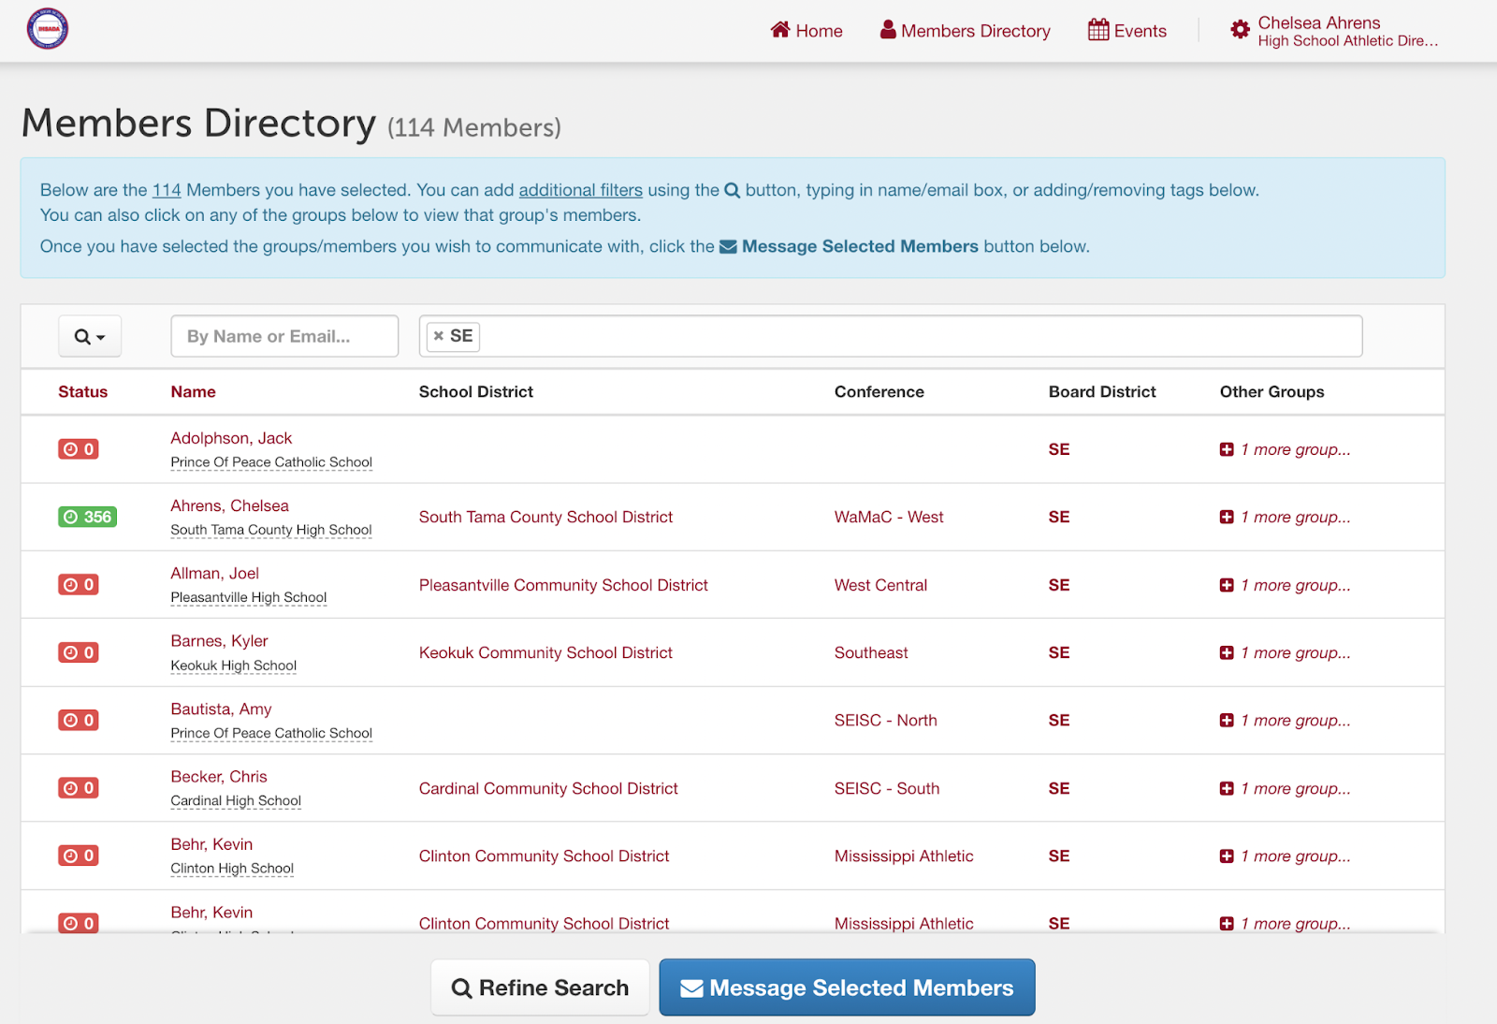
5. Finally, you will land on the screen where you will draft an email, attach a document (if needed) and send the email to only the members in the FILTERED GROUP. (For best email quality, we suggest using HTML Body)
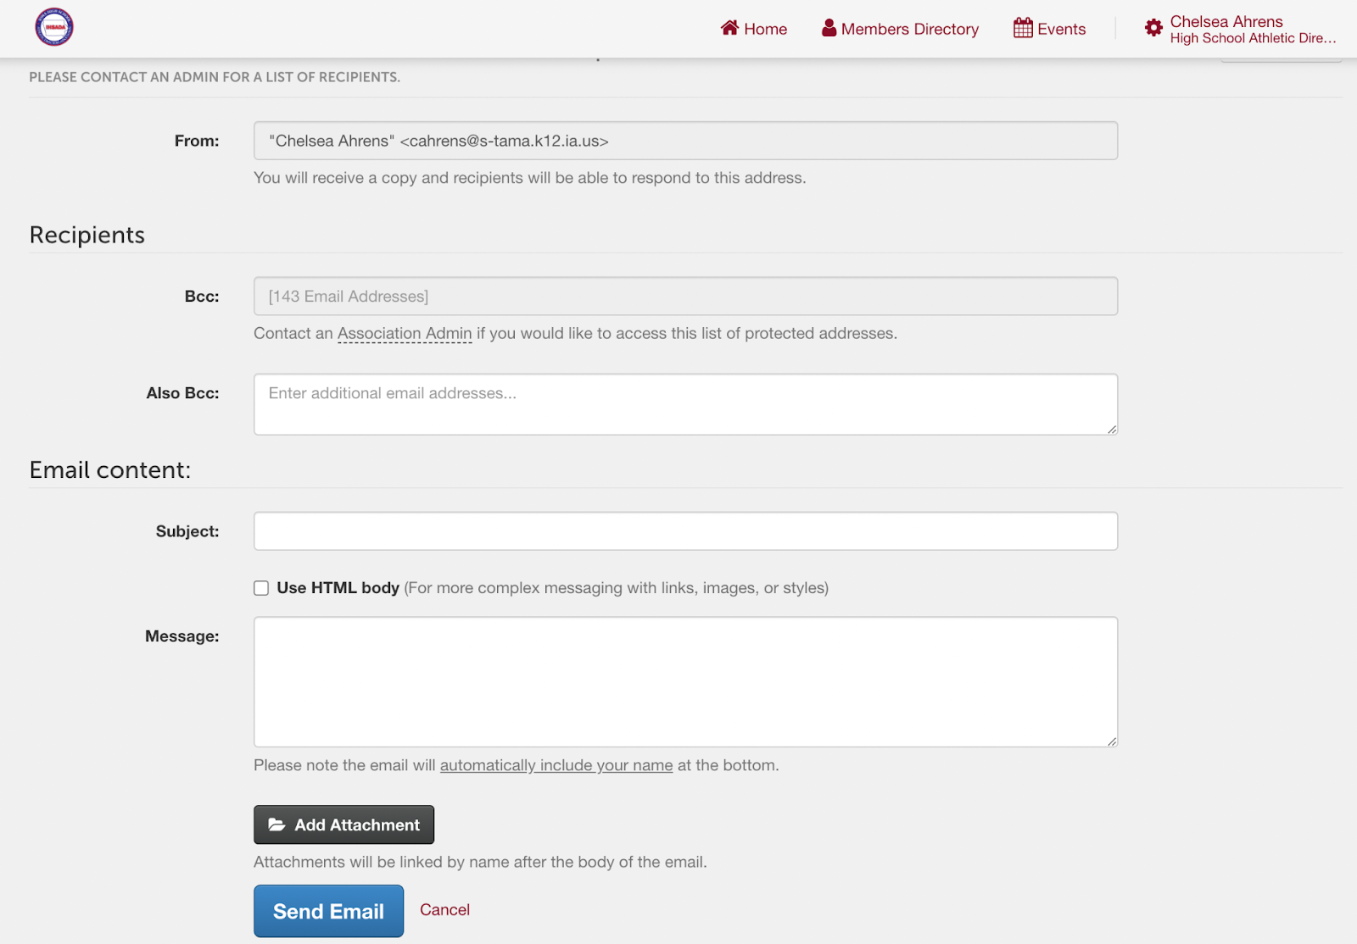

If you have any questions, please email IHSADA AMP SUPPORT at support@finalforms-amp.com

